# CENTRAL BANK SMART CONTRACT

# 1.INTRODUCTION:

Central bank digital currencies (CBDCs) are the digital form of a government-issued currency that isn't pegged to a physical commodity. They are issued by central banks, whose role is to support financial services for a nation's government and its commercial-banking system, set monetary policy, and issue currency.

# 1.1 PROJECT OVERVIEW:

A central bank is a pivotal financial institution that plays a critical role in managing a country's monetary and financial system. Its primary responsibilities include controlling the money supply, regulating the banking industry, and maintaining economic stability. Central banks are typically government-owned or government-controlled entities and are considered the "bank of banks." They are entrusted with a range of important functions, including:

* **Objective:** The primary objective of a central bank's smart contract project could be to enhance the efficiency, security, and transparency of monetary and financial transactions. Smart contracts are self-executing agreements with predefined rules, making them suitable for various financial and regulatory applications.
* **CBDC Implementation**: Many central banks are considering the issuance of CBDCs, which are digital representations of the national currency. Smart contracts can be used to facilitate the issuance, distribution, and management of CBDCs. For instance, a smart contract could automatically execute transactions for payments, settlements, and financial services.
* **Interbank Settlement**: Smart contracts can be used to streamline interbank settlement processes. By implementing smart contracts on a blockchain, central banks can facilitate instant and secure settlement between financial institutions, reducing the time and cost associated with traditional clearing and settlement systems.
* **Regulatory Compliance**: Central banks can use smart contracts to automate and enforce regulatory compliance within the financial system. Smart contracts can monitor and ensure that financial institutions adhere to capital requirements, anti-money laundering (AML) and know-your-customer (KYC) regulations, and other relevant rules.
* **Open Banking and Financial Inclusion**: Smart contracts can be leveraged to support open banking initiatives and promote financial inclusion. They can enable secure and transparent access to financial services for underserved populations, ensuring fair and equitable access to the financial system.
* **Privacy and Security**: Privacy and security are crucial in any central bank digital currency or smart contract project. Encryption and consensus mechanisms are implemented to protect the data and transactions while ensuring that only authorized parties can participate.
* **Testing and Pilots**: Before deploying smart contracts in a live environment, central banks typically conduct extensive testing and pilot programs to identify and address any potential issues or vulnerabilities. These tests may involve a limited group of financial institutions or the general public.
* **Collaboration:** Central banks often collaborate with other stakeholders, including technology firms, financial institutions, and regulatory bodies, to ensure the success and broad acceptance of their smart contract projects.
* **Research and Development**: Continuous research and development are necessary to adapt to changing technological landscapes and to keep pace with emerging trends in blockchain and smart contract technologies.
* It's important to note that the specific implementation and scope of central bank smart contract projects can vary significantly based on the country, its financial system, regulatory environment, and technology infrastructure. Additionally, given the rapidly evolving nature of blockchain and CBDC developments, you should consult up-to-date sources and official announcements from central banks to gain insights into the latest projects and initiatives in this field.

**1.2 PURPOSE:**

The purpose of central bank smart contracts can be multifaceted and is closely related to improving the efficiency, transparency, and security of central banking operations. Here are some of the key purposes of central bank smart contracts:

* **Monetary Policy Implementation**: Smart contracts can automate the execution of monetary policy decisions made by central banks. This includes the management of interest rates, open market operations, and the control of the money supply. Smart contracts enable the central bank to more precisely and efficiently implement its monetary policy, influencing economic stability and inflation control.
* **Central Bank Digital Currency (CBDC)**: Central banks are exploring the issuance and management of CBDCs, and smart contracts are crucial for their implementation. Smart contracts can govern the creation, distribution, and use of CBDCs, ensuring that they meet the central bank's objectives for economic control and financial stability.
* **Interbank Settlement**: Smart contracts can be used to streamline interbank settlements. These self-executing agreements can automate and expedite the settlement of transactions between financial institutions, reducing settlement times and counterparty risk.
* **Payment Systems**: Central banks can leverage smart contracts to enhance their payment systems. Smart contracts can support real-time, secure, and cost-effective payment solutions, improving the overall payment infrastructure within a country.
* **Regulatory Compliance**: Smart contracts can enforce and automate regulatory compliance, particularly in areas such as anti-money laundering (AML) and know-your-customer (KYC) requirements. This ensures that financial institutions adhere to the central bank's regulatory standards, enhancing the integrity of the financial system.
* **Transparency and Accountability**: Smart contracts executed on a blockchain provide a transparent and immutable record of transactions. This transparency can enhance accountability and auditability, both for the central bank's own operations and for the financial institutions it regulates.
* **Security**: The security of transactions and data is a paramount concern for central banks. Smart contracts, when implemented properly, can provide a high level of security through cryptographic techniques and consensus mechanisms, reducing the risk of fraud and unauthorized access.
* **Operational Efficiency**: Smart contracts can automate routine financial and administrative tasks within the central bank, reducing the need for manual intervention and improving operational efficiency.
* **Research and Analysis**: Central banks can use smart contracts for research and data analysis purposes. The transparency of blockchain data and the automation of transactions can aid central banks in monitoring economic trends, conducting research, and making data-driven decisions.
* **Financial Inclusion**: Smart contracts can help central banks promote financial inclusion by providing secure and accessible digital financial services to underserved populations. This can help extend the benefits of modern financial systems to a broader segment of the population.
* The exact purposes of central bank smart contracts may vary from one institution to another and can depend on the specific goals and priorities of the central bank, as well as the regulatory and technological environment in which they operate. These purposes ultimately aim to enhance the central bank's ability to fulfill its core mandate of maintaining economic stability and fostering financial system integrity.

**2. LITERATURE SURVEY:**

* 1. **EXISTING PROBLEM:**

Put simply, a CBDC would most likely be the single largest assault to financial privacy since the creation of the Bank Secrecy Act and the establishment of the third‐​party doctrine. The threat to freedom that a CBDC could pose is closely related to its threat to privacy.

* 1. **REFERENCES:**
* **BIS (Bank for International Settlements)**: The BIS often publishes reports and research related to central bank digital currencies and blockchain technology. Visit the BIS website and search for relevant publications.
* **Central Bank Websites**: Check the official websites of central banks in your country and others to find research papers, speeches, and reports related to CBDCs and smart contracts.
* **Academic Journals**: Search academic databases like JSTOR, Google Scholar, or academic journals in economics, finance, and blockchain technology for research papers and articles on CBDCs and smart contracts.
* **Financial News Outlets**: Financial news websites and publications often cover developments in the central banking sector. Look for articles and reports on CBDCs and smart contracts.
* **Whitepapers and Research Papers**: Many blockchain and fintech companies release whitepapers and research papers related to the use of blockchain and smart contracts in central banking. Look for these documents on the websites of relevant companies and organizations.
* **International Organizations**: Organizations like the International Monetary Fund (IMF) and the World Bank may have research and publications related to the use of smart contracts by central banks.
* **Blockchain Conferences**: Proceedings and presentations from blockchain and fintech conferences often include discussions on central bank digital currencies and smart contracts.
* **Government Reports**: Look for government reports and policy documents related to the development and regulation of central bank digital currencies and smart contracts.
* **Academic Research Institutions**: Research institutions and universities with a focus on blockchain and financial technology may have relevant studies and publications.
* **Cryptocurrency and Blockchain Forums:** Online forums and communities dedicated to cryptocurrencies and blockchain technology often discuss developments in CBDCs and smart contracts. Websites like Bitcointalk and Reddit's r/ethereum subreddit can be good resources.
* <http://www3.weforum.org/docs/WEF_CBDC_Policymaker_Toolkit.pdf>
* <https://www.bankofcanada.ca/2020/06/staff-analytical-note-2020-10/>
  1. **PROBLEM STATEMENT DEFINITION:**

The Central Bank Smart Contract represents a pioneering application of blockchain technology, aimed at establishing a decentralized banking infrastructure. This innovative smart contract empowers users to conduct banking transactions securely, with full transparency and efficiency harnessed from the capabilities of blockchain. Blockchain technology emerged as a solution to address these challenges by providing decentralized nodes within the banking ecosystem, thereby facilitating a transparent, end-to-end verification process. This technology serves as a transformative replacement for the conventional banking system, boasting distributed architecture, non-repudiation features, and robust security safeguards. As a Blockchain expert within a prominent corporate bank, I have been entrusted with the responsibility of designing a smart contract tailored for banking transactions.

**Description of the Problem:** A brief and clear explanation of the problem or issue. This part provides context and helps readers understand the nature of the problem.

**Scope**: The extent or boundaries of the problem, indicating what is included and what is not. It helps in defining the problem's boundaries and preventing scope creep.

**Impact**: An explanation of the consequences or implications of the problem. This section discusses why the problem is significant and why it needs attention.

**Stakeholders:** Identification of the individuals, groups, or organizations affected by the problem, as well as those who have a vested interest in its resolution.

**Goals and Objectives:** The desired outcomes or solutions that need to be achieved to address the problem. This part outlines what success looks like.

**3. IDEATION & PROPOSED SOLUTION:**

**3.1 EMPATHY MAP CANVAS:**

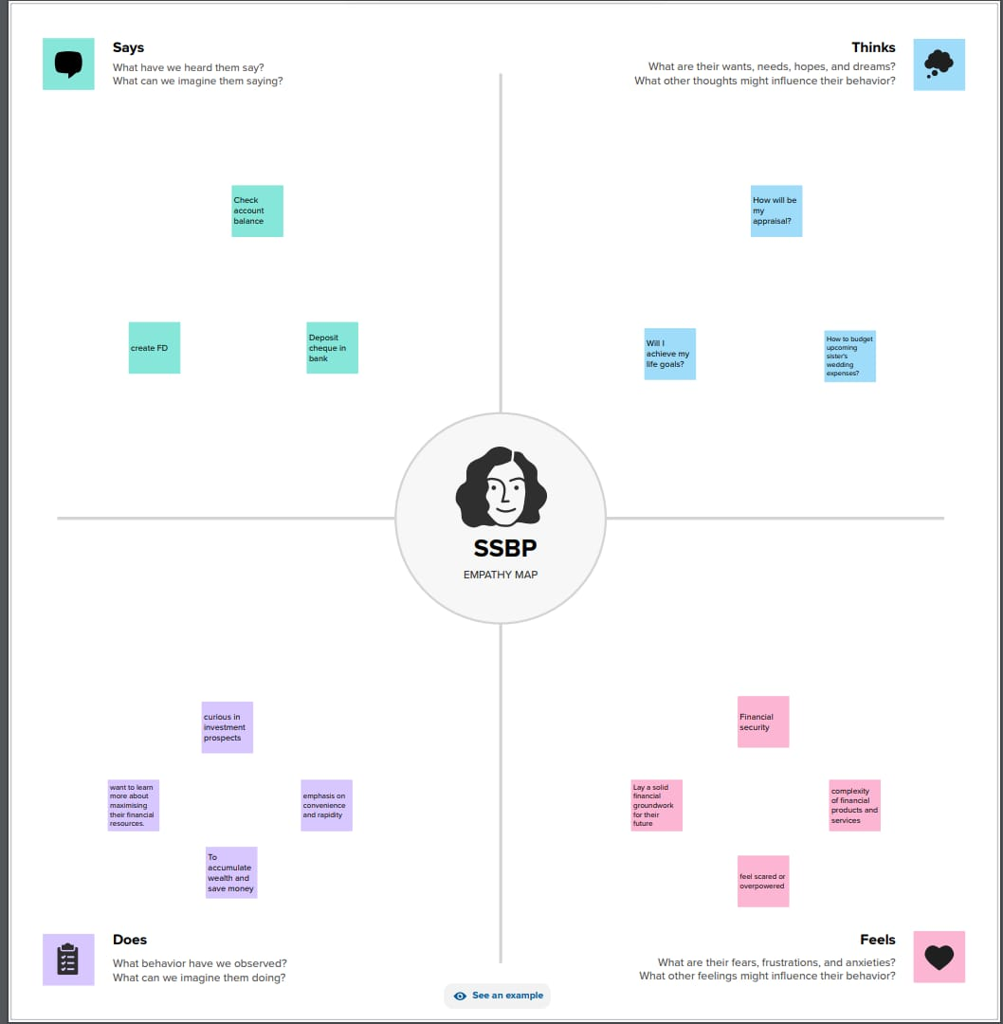

**3.2 IDEATION & BRAINSTORMING:**

**STEP 1: Problem statement**

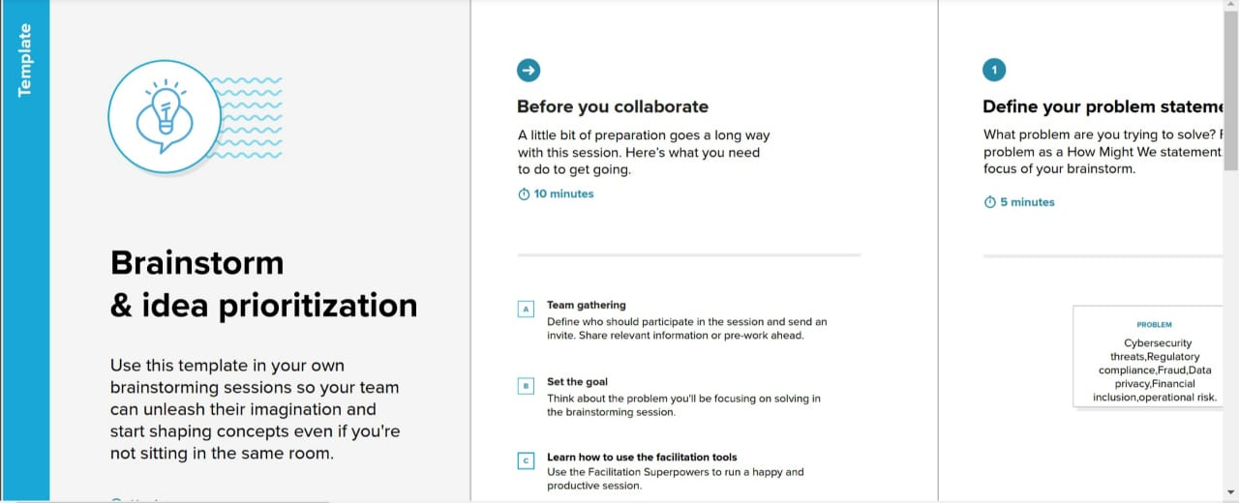

## STEP 2: Brainstorm

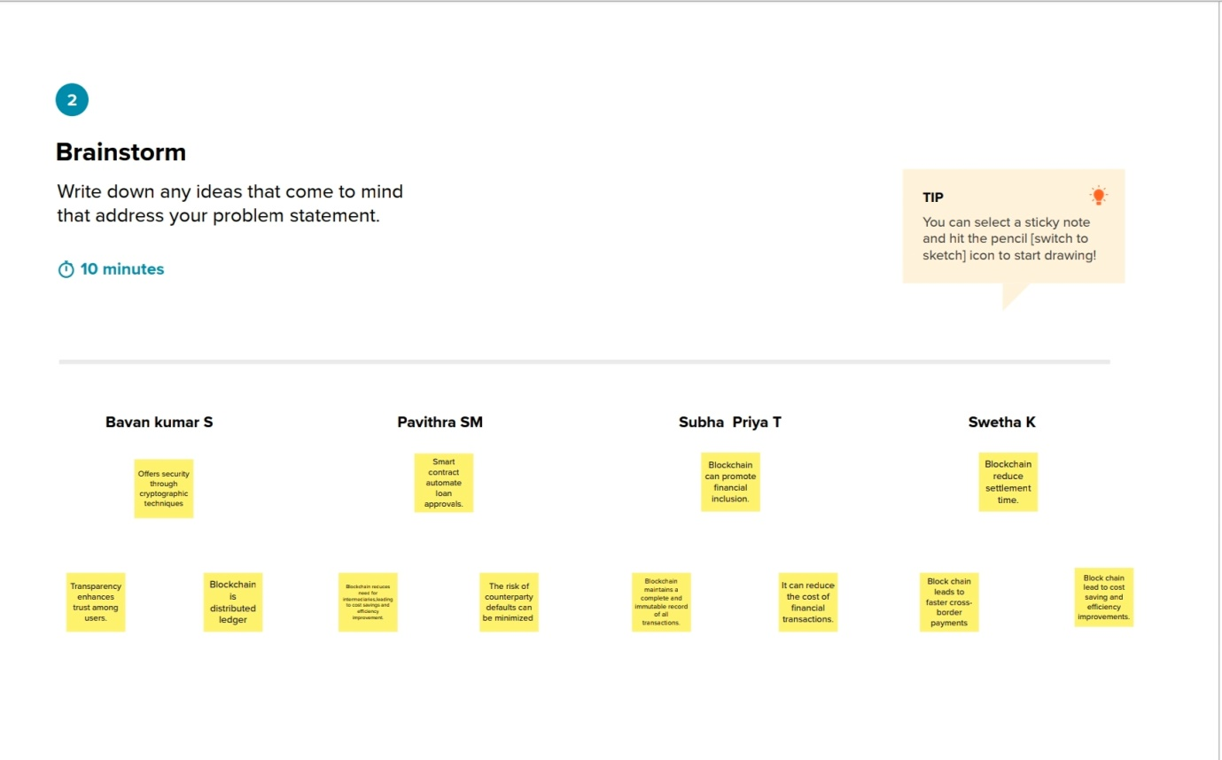

**Step 3: Group Ideas**

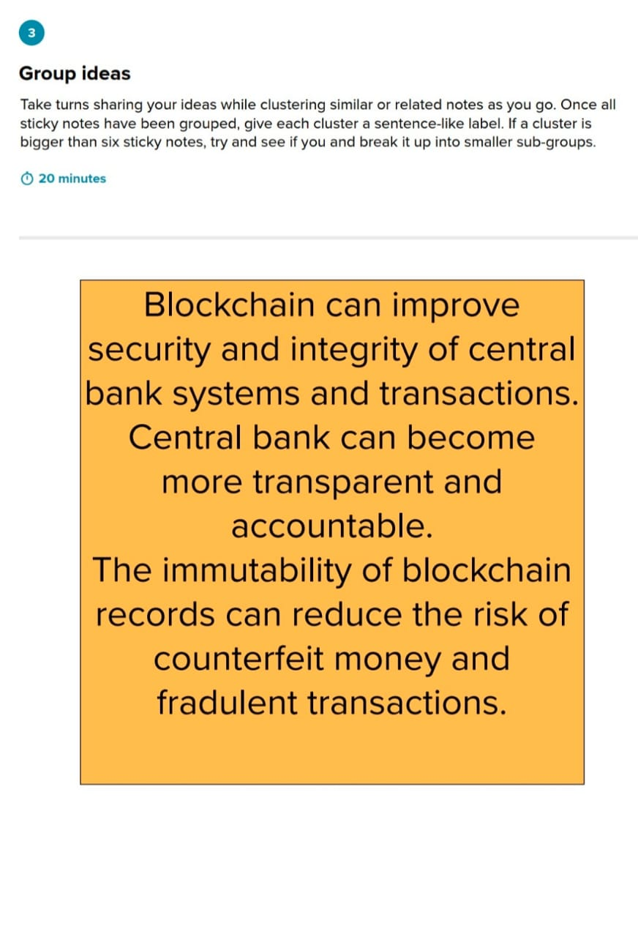

### Step 4:Prioritize

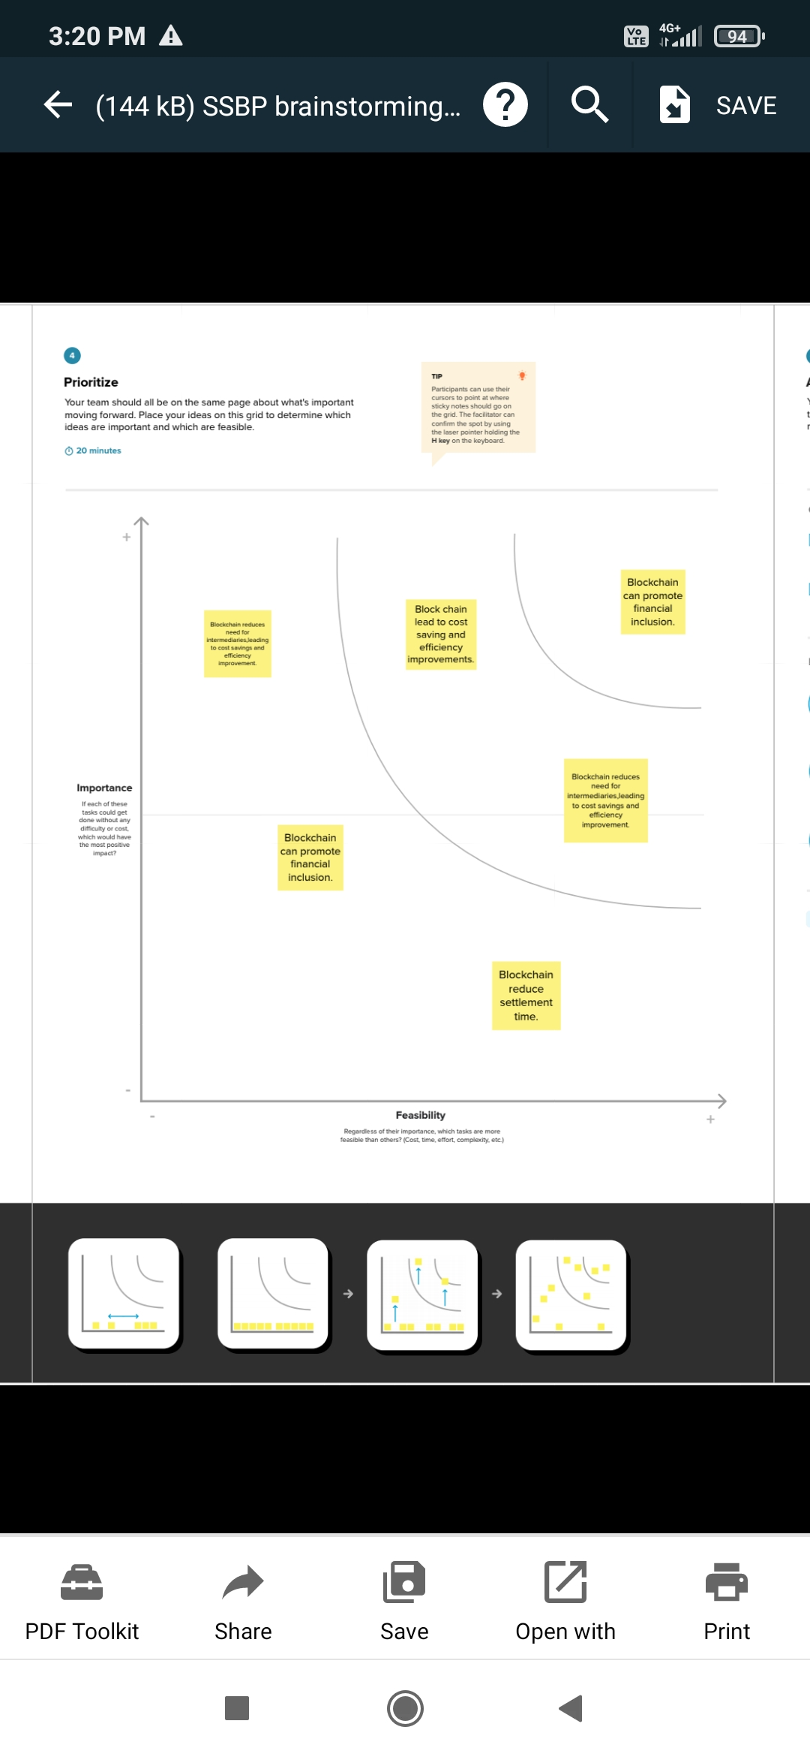

# 4. REQUIREMENT ANALYSIS:

# 4.1 FUNCTIONAL REQUIREMENT:

# Functional requirements in central bank smart contracts define the specific functions and capabilities that the smart contract must possess to meet the central bank's objectives and regulatory requirements. These requirements are essential for ensuring that the smart contract can effectively perform its intended tasks within the central banking system. Below are some functional requirements typically associated with central bank smart contracts:

# 1.Issuance and Redemption of CBDCs:

# The smart contract should be able to issue new central bank digital currencies (CBDCs) when authorized and redeem them when requested by participants.

# It should maintain an accurate record of the total CBDCs in circulation and track individual CBDC ownership.

# 2. Transaction Processing:

# The smart contract should facilitate secure and efficient transaction processing, enabling the transfer of CBDCs between authorized parties.

# It should support various transaction types, such as peer-to-peer transfers, interbank settlements, and payment processing.

# 3. Monetary Policy Implementation:

# The smart contract should allow the central bank to execute monetary policy decisions. For example, it should have the capability to adjust interest rates and influence money supply through predefined rules.

# 4. Privacy and Security:

# Privacy requirements should be defined to protect sensitive transaction data, ensuring that only authorized parties have access to specific transaction details.

# Security measures, including cryptographic techniques and access controls, should be in place to prevent unauthorized access and fraud.

# 5. Regulatory Compliance:

# The smart contract should be designed to enforce and comply with relevant financial regulations, including anti-money laundering (AML) and know-your-customer (KYC) requirements.

# It should facilitate reporting and auditing as necessary for regulatory oversight.

# 6. Interoperability:

# If applicable, the smart contract should be able to interoperate with other central bank smart contracts and systems, both within and outside the central banking ecosystem.

# It should support cross-border transactions and adhere to international standards.

# 7. User Authentication and Authorization:

# The smart contract should have mechanisms for user authentication and authorization, ensuring that only authorized individuals or entities can initiate transactions or access specific functions.

# 8. Reporting and Auditing:

# The contract should provide the ability to generate transaction logs and reports for auditing and oversight purposes.

# It should maintain a historical record of transactions for transparency and accountability.

# 9. Disaster Recovery and Redundancy:

# The smart contract should have mechanisms for disaster recovery and redundancy to ensure operational resilience, especially in cases of system failures or unforeseen events.

# 10. Upgradeability and Maintenance:

# The contract should be designed with considerations for future upgrades and maintenance to accommodate evolving technological and regulatory requirements.

# 11. **Transaction Fees and Pricing Structure**:

# The contract should specify the fee structure for using the smart contract's services, including transaction fees, and any pricing changes or adjustments.

# 12. Consensus Mechanism:

* If applicable, the contract should define the consensus mechanism used to validate and confirm transactions within the blockchain network.

**4.2 NON-FUNCTIONAL REQUIREMENTS:**

Non-functional requirements in the context of central bank smart contracts specify qualities or characteristics that the smart contract should exhibit, rather than specific functions or features. These requirements are essential for ensuring that the smart contract performs reliably, efficiently, and securely. Non-functional requirements typically address aspects such as performance, scalability, security, and usability. Here are some common non-functional requirements for central bank smart contracts:

**1. Security:**

* **Data Protection:** The smart contract should use encryption and other security measures to protect sensitive data from unauthorized access.
* **Authentication and Authorization**: It should implement robust authentication mechanisms to verify the identity of users and ensure that only authorized individuals or entities can interact with the contract.
* **Secure Coding Practices**: The contract's code should adhere to secure coding practices to prevent vulnerabilities and exploitation by malicious actors.

**2. Scalability:**

* The smart contract should be able to handle an increasing number of transactions and users without a significant degradation in performance

.

**3. Performance:**

* **Response Time**: The contract should process transactions and provide responses within an acceptable timeframe to ensure efficient operation.
* **Throughput**: It should be capable of handling a minimum number of transactions per second to meet the demands of a high-volume financial system.

**4. Availability and Reliability:**

* The contract should be highly available, with minimal downtime or disruptions, to ensure continuous operation.
* It should have mechanisms for disaster recovery and redundancy to maintain reliability in case of system failures.

**5. Auditability and Traceability:**

* The smart contract should support auditing and traceability of transactions for transparency and accountability.

**6. Privacy:**

* It should have privacy features that protect sensitive transaction data and the identities of users, in compliance with privacy regulations and central bank policies.

**7. Interoperability:**

* If applicable, the contract should be designed to interoperate with other systems, both within the central bank's ecosystem and with external entities.

**8. Usability:**

* The contract's user interfaces should be user-friendly and intuitive, making it easy for authorized users to interact with the smart contract.

**9. Compliance:**

* The contract should adhere to regulatory requirements and international standards, such as anti-money laundering (AML) and know-your-customer (KYC) regulations.

**10. Upgradability and Maintenance:**

* The contract should be designed to allow for future upgrades and maintenance, with minimal disruption to ongoing operations.

**11. Resource Efficiency:**

* The contract should use system resources efficiently to minimize energy consumption and infrastructure costs.

**12. Consensus Mechanism:**

* If applicable, the choice of consensus mechanism should meet the performance and security requirements of the contract.

**13. Geographical Considerations:**

* The contract should take into account geographic considerations, such as data residency requirements, when storing or processing data.

**5. PROJECT DESIGN:**

**5.1 DATA FLOW DIAGRAMS & USER DIAGRAM:**

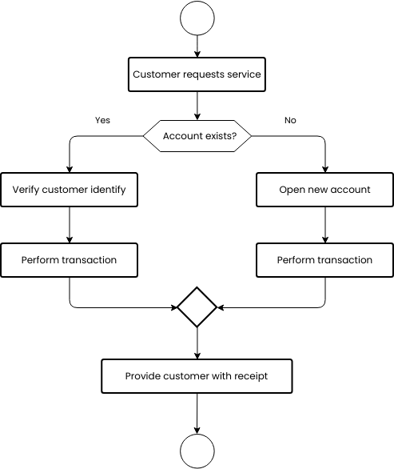

**USER STORIES:**

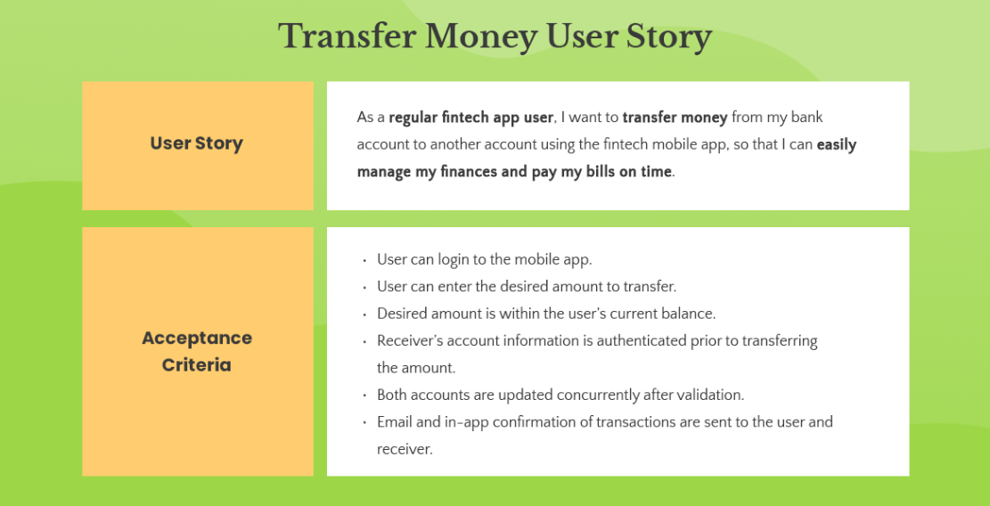

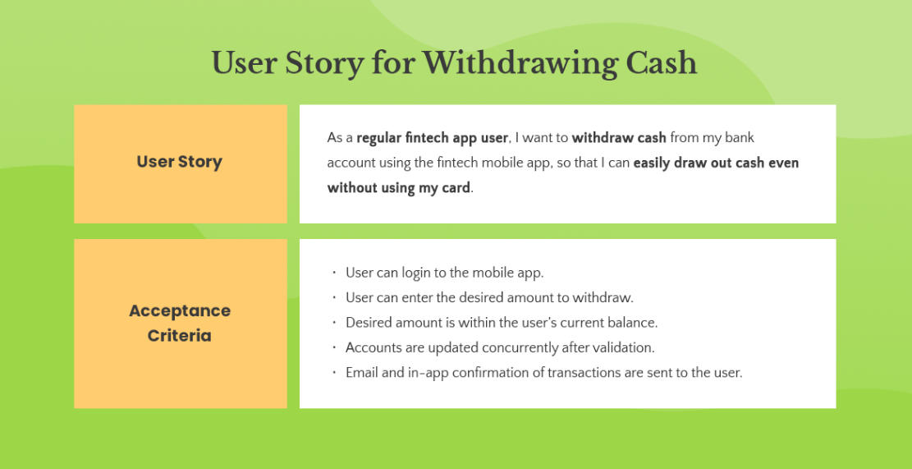

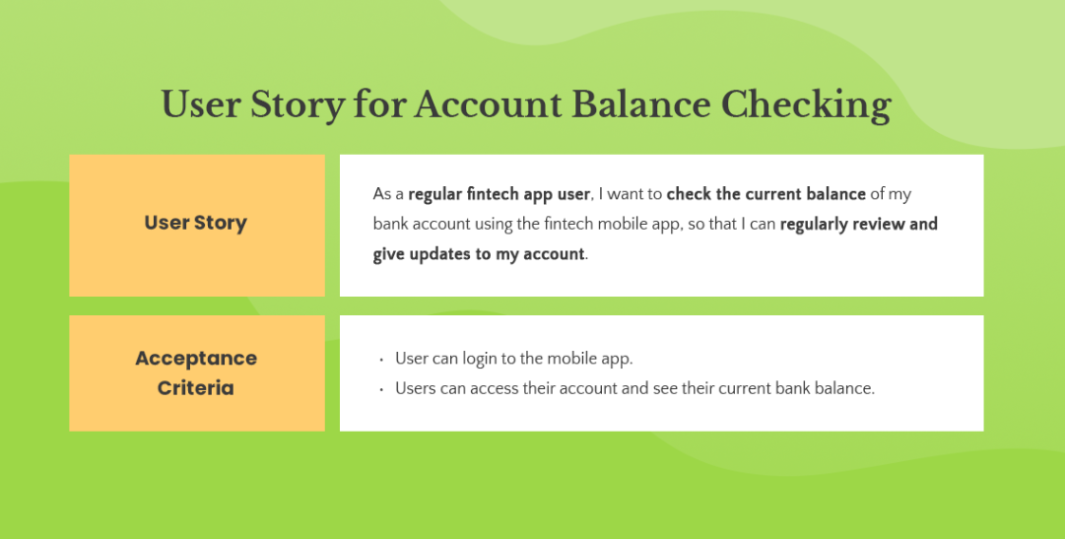

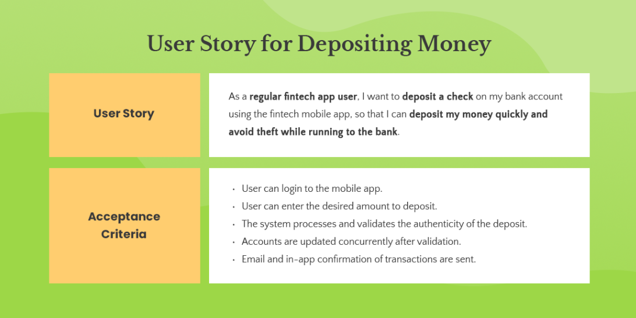

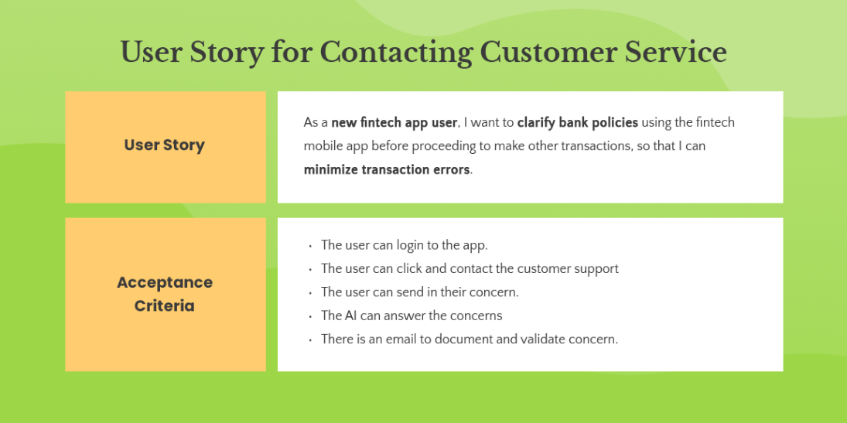

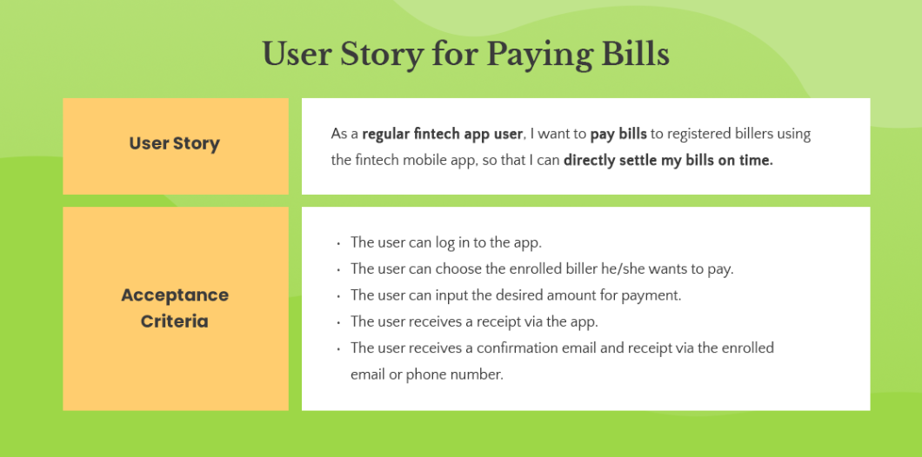

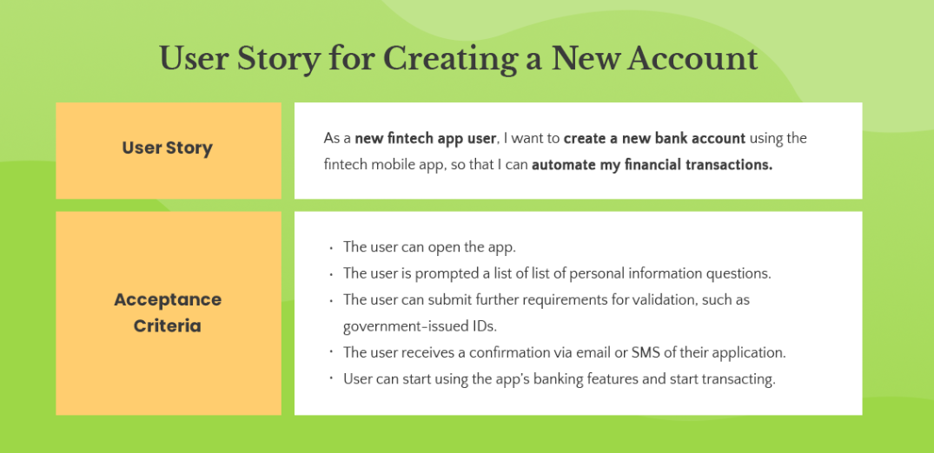

**5.2 SOLUTION ARCHITECTURE:**

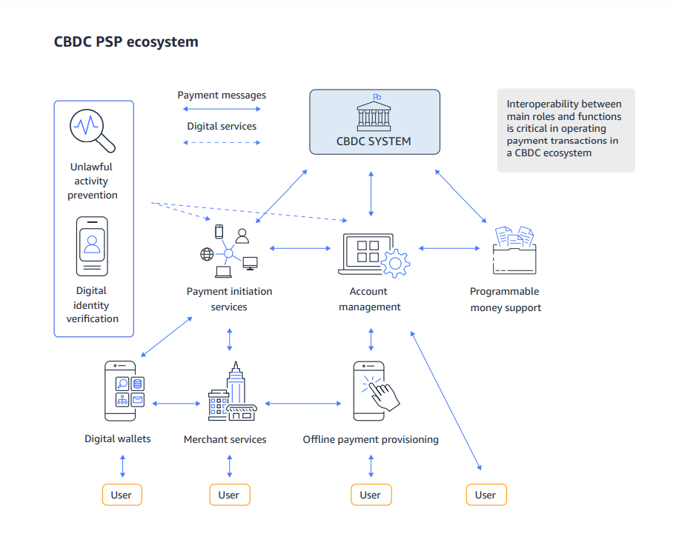

**6. PROJECT PLANNING & SCHEDULING:**

**6.1 TECHNICAL ARCHITECTURE:**

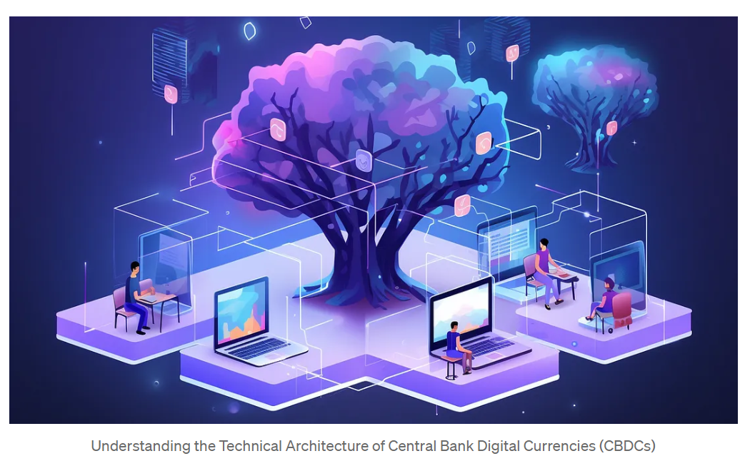

Central Bank Digital Currencies (CBDCs) have gained significant attention in recent years as digital transformation continues to reshape the financial landscape. As a software developer, it’s crucial to comprehend the technical architecture underlying CBDCs to leverage their potential and contribute to the evolution of digital economies. In this article, we’ll delve into the intricacies of CBDC technical architecture, exploring key concepts, design considerations, and code examples to facilitate a deeper understanding.

**6.2 SPRINT PLANNING & ESTIMATION:**

Sprint planning and estimation for the development of a smart contract for a central bank involves breaking down the project into manageable tasks, prioritizing them, and determining the time required for each task. Here's a step-by-step guide on how to plan and estimate the development of a central bank smart contract:

**1. Project Initiation:**

* Define the objectives and requirements of the smart contract. Understand its purpose, whether it's for issuing digital currency, regulating financial transactions, or any other specific use case.

**2. Assemble a Cross-Functional Team:**

* Form a team that includes blockchain developers, legal experts, economists, compliance specialists, and project managers. This team will be responsible for sprint planning and execution.

**3. Create a Product Backlog:**

* Develop a product backlog, which is a prioritized list of tasks and features that the smart contract needs to encompass. These tasks should align with the central bank's goals and regulatory requirements.

**4. Prioritize Backlog Items:**

* Prioritize the items on the backlog based on their importance, regulatory mandates, and dependencies. Ensure that the most critical features are addressed first.

**5. Define Sprint Length:**

* Determine the sprint duration, which can range from 2 to 4 weeks or longer, depending on the complexity and nature of the tasks.

**6. Sprint Planning Meeting:**

* Hold a sprint planning meeting at the beginning of each sprint to select items from the product backlog for the upcoming sprint.

**7. Define Sprint Goals:**

* Set clear, specific goals for the sprint. For instance, if the objective is to build a specific feature of the smart contract, that should be the focus of the sprint.

**8. Task Breakdown:**

* Break down the selected items into granular tasks. For example, if a goal is to implement a specific feature, tasks could include code development, legal review, compliance assessment, and testing.

**9. Assign Tasks:**

* Assign tasks to team members based on their skills and expertise, taking into account their role in the development process.

**10. Estimation:**

* Estimate the time required for each task, considering factors such as complexity, dependencies, regulatory compliance, and testing. Use techniques like story points or time-based estimates.

**11. Execute the Sprint:**

* Throughout the sprint, team members work on their assigned tasks with the primary goal of achieving the sprint objectives.

**12. Daily Stand-up Meetings:**

* Conduct daily stand-up meetings to track progress, discuss any roadblocks, and make adjustments to the plan as necessary.

**13. Sprint Review:**

* At the end of the sprint, hold a review meeting to assess what was accomplished and whether the sprint goals were achieved.

**14. Sprint Retrospective:**

* Conduct a retrospective meeting to identify areas for improvement and adjust processes for future sprints.

**15. Repeat:**

* Continue with subsequent sprints, regularly reassessing and reprioritizing the product backlog based on evolving regulatory requirements, feedback, and project status.
* Smart contracts developed for central banks require strict adherence to legal and regulatory requirements. Therefore, legal review and compliance assessment should be integrated into the sprint planning and execution processes. Security and risk assessments are also critical in ensuring the contract's integrity and functionality. Be prepared for changes in requirements and regulations that may necessitate adjustments during the project.

**6.3 SPRINT DELIVERY SCHEDULE:**

A sprint delivery schedule for a smart contract project typically involves setting up a series of sprints with specific goals and milestones for the development and delivery of the contract. Here's a basic outline of how you might structure a sprint delivery schedule for a smart contract:

**1. Project Initiation:**

* Define the project objectives, scope, and overall timeline.

**2. Sprint 0: Planning and Setup (Optional):**

* This initial sprint may be used for project setup, such as selecting a development team, defining roles, and setting up development environments. It's optional and may not include specific smart contract development.

**3. Sprint 1: Project Kickoff:**

* Start with a sprint that includes high-level project planning and requirements gathering. Define the contract's purpose and scope.

**4. Sprint 2 and Onward: Development Sprints:**

* Begin the development sprints for the smart contract. The number of sprints will depend on the complexity of the contract and the specific features and functionality it needs. Each development sprint can typically last 2-4 weeks, but it can be adjusted based on your project's needs.
* In each development sprint, the team works on developing specific features or components of the smart contract.
* Conduct daily stand-up meetings, sprint planning, and sprint reviews as part of each sprint.

**5. Regulatory and Legal Review (Intermittent):**

* Depending on the regulatory environment and the central bank's specific requirements, you may need to intersperse development sprints with regulatory and legal review sprints. These sprints are for legal experts to review the contract for compliance with financial regulations.

**6. Sprint Review and Stakeholder Demos (End of Each Sprint):**

* At the end of each development sprint, hold a sprint review meeting to demonstrate the completed features or components to stakeholders. This helps ensure alignment with expectations.

**7. Testing and Quality Assurance (Intermittent):**

* Integrate testing and quality assurance activities within the sprint schedule. This may include unit testing, integration testing, security testing, and compliance testing.

**8. External Audit and Security Assessment (As Needed):**

* Schedule a sprint for external audit and security assessment if required by regulatory authorities or best practices.

**9. Sprint Retrospective (End of Each Sprint):**

* After each sprint, hold a retrospective meeting to review the sprint, identify areas for improvement, and make process adjustments.

**10. User Acceptance Testing (UAT) and Compliance Verification (Intermittent):**

* Conduct UAT and compliance verification activities as needed, involving relevant stakeholders.

**11. Documentation and Final Review:**

* Plan a sprint for comprehensive documentation of the smart contract, including code documentation and legal documentation. Review the contract's compliance and quality.

**12. Deployment:**

* After successful completion of all development, testing, legal review, and audits, plan a deployment sprint to release the smart contract to the designated blockchain network.

**13. Post-Deployment:**

* Continue to monitor the smart contract after deployment for any issues, bug fixes, and updates.

**14. Ongoing Support and Maintenance:**

* Establish an ongoing support and maintenance plan for the smart contract, which may include regular sprints for maintenance, updates, and enhancements.
* The sprint delivery schedule for a smart contract project should be adaptable to the specific requirements and regulatory environment of the central bank. The schedule should also account for the complexity of the contract, the availability of resources, and the need for thorough legal and regulatory compliance. It's crucial to maintain clear communication and collaboration among the development team, stakeholders, and legal experts throughout the project.

**7. CODING & SOLUTIONING:**

**7.1 FEATURE 1:**

**Tokenization of Assets**: Central banks can use smart contracts to tokenize assets like government bonds, making them more accessible and tradable.

**Disaster Recovery and Redundancy**: Smart contracts can be designed to ensure that essential central bank functions continue even in the event of system failures or disasters.

**Transparency and Auditability**: All actions and transactions executed through smart contracts can be recorded on a blockchain, ensuring transparency and making it easier for auditors to review central bank activities.

**Privacy and Security**: Central bank smart contracts need robust security measures to protect sensitive data and maintain the privacy of users while ensuring regulatory compliance.

**Interoperability**: Smart contracts developed by central banks should be designed to work seamlessly with other financial institutions and payment systems to foster interoperability.

**7.2 FEATURE 2:**

**Cross-Border Transactions:** Smart contracts can streamline and automate cross-border transactions and forex trading while ensuring compliance with exchange rate policies.

**Crisis Response:** In times of economic crises, smart contracts can be used to automatically implement emergency measures, such as liquidity provision or capital controls.

**Open Banking and APIs:** Central banks can provide APIs and smart contract interfaces to enable fintech innovation and integration with third-party financial services.

**Decentralization:** Some central banks may explore decentralized blockchain-based systems to reduce single points of failure and enhance security.

It's important to note that the adoption of smart contracts by central banks may vary depending on the country's regulatory framework, technological infrastructure, and economic priorities. The features and capabilities of central bank smart contracts may evolve over time as technology and the financial landscape change.

**8. PERFORMANCE TESTING:**

**8.1 PERFORMANCE METRICS:**

Measuring the performance of central bank smart contracts is essential to ensure their effectiveness and efficiency in achieving the intended objectives. Here are some key performance metrics that can be used to evaluate central bank smart contracts:

**Transaction Speed:** This metric assesses the speed at which smart contracts process transactions. Faster transaction speeds can improve the efficiency of payment systems and reduce settlement times.

**Throughput:** Throughput measures the number of transactions that a smart contract can process in a given time period. Higher throughput is essential for scalability and handling increased transaction volumes during peak periods.

**Cost Efficiency:** Evaluating the cost-effectiveness of smart contracts is crucial. It involves measuring the operational costs associated with maintaining and running the smart contract infrastructure compared to traditional systems.

**Security:** Security metrics assess the robustness of smart contracts in terms of protection against hacking, fraud, and unauthorized access. It includes evaluating the number of security incidents and their impact.

**Transparency:** Measuring the transparency of smart contracts involves assessing the extent to which transactions and operations are publicly accessible and verifiable on the blockchain.

**Auditability:** Smart contracts should be designed to facilitate audits. Metrics related to auditability evaluate how easily the code and transaction history can be reviewed for compliance and accountability purposes.

**Reliability and Uptime:** Uptime metrics measure the availability of the smart contract system. Downtime can disrupt financial operations, so it's essential to minimize it.

**User Adoption:** Examining the adoption of central bank digital currencies (CBDCs) or other financial instruments facilitated by smart contracts can provide insights into their success.

**Interoperability:** Assessing the ability of smart contracts to work with other financial systems and institutions is crucial. Metrics can measure the number and success of integrations with third-party services.

**Scalability:** Scalability metrics evaluate how well the smart contract system can handle an increasing number of users and transactions without compromising performance.

**Regulatory Compliance:** Central bank smart contracts must comply with existing financial regulations. Metrics can measure the level of compliance and the extent to which regulatory requirements are met.

**Customer Satisfaction:** Collecting feedback from users and stakeholders can gauge their satisfaction with the smart contract system, helping to identify areas for improvement.

**Environmental Impact:** With the increasing focus on sustainability, measuring the environmental impact of the infrastructure supporting smart contracts can be important. This includes energy consumption and carbon emissions.

**Smart Contract Execution Accuracy:** Evaluating the accuracy of smart contract execution is vital to ensure that they perform as intended and don't lead to unexpected errors or disputes.

**Time-to-Market for Updates:** Measuring the time it takes to implement updates or changes to smart contracts can indicate how agile and responsive the central bank is in adapting to evolving needs and regulatory requirements.

**Resilience to Cyberattacks:** Assessing the ability of smart contracts to withstand and recover from cyberattacks is critical to maintaining trust in the system.

**Fraud Prevention:** Metrics related to fraud prevention can measure the effectiveness of smart contracts in identifying and mitigating fraudulent transactions.

These performance metrics can vary depending on the specific use case and objectives of the central bank's smart contracts. Regular monitoring and evaluation are essential to ensure that the smart contracts continue to meet their intended goals and adapt to changing circumstances and technological advancements.

**9. RESULTS:**

**9.1 OUTPUT SCREENSHOTS:**

# 

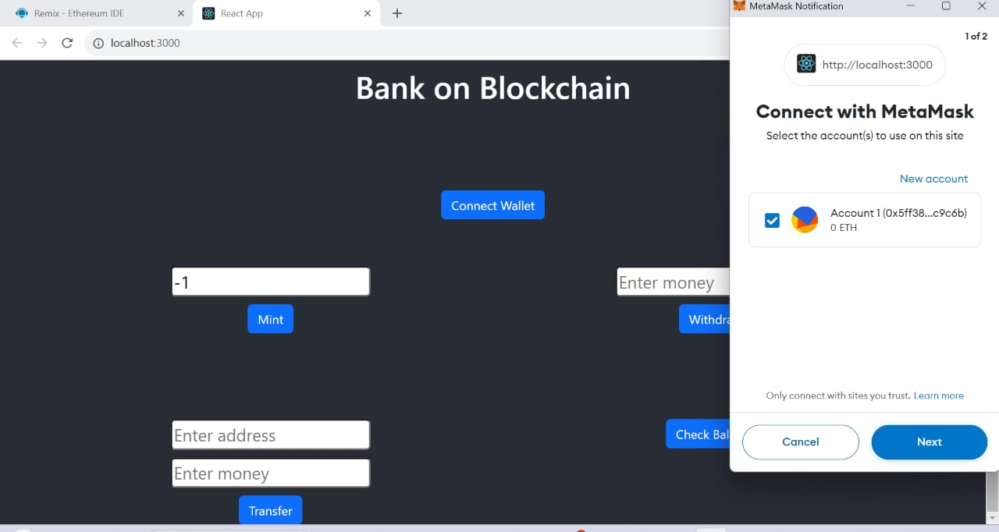

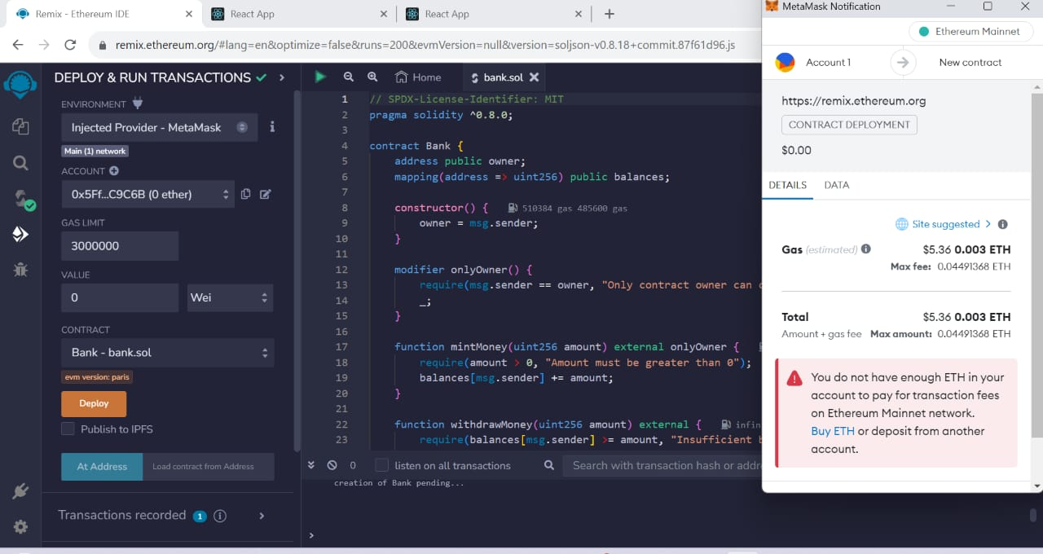

**10. ADVANTAGES & DISADVANTAGES:**

**ADVANTAGES:**

* **Efficiency:** Smart contracts can automate and streamline various financial processes, reducing the need for manual intervention and paperwork, which can lead to cost savings and faster transaction processing.
* **Transparency:** Transactions and operations executed through smart contracts are recorded on a blockchain, providing a transparent and immutable ledger, which enhances accountability and reduces the risk of fraud.
* **Security:** Smart contracts use cryptographic techniques and consensus mechanisms to secure transactions, making them highly resistant to hacking and fraud.
* **Reduced Counterparty Risk:** Smart contracts automatically execute when predefined conditions are met, reducing the counterparty risk associated with traditional financial agreements.
* **Real-Time Settlement:** Transactions facilitated by smart contracts can settle in real-time, which can enhance liquidity and reduce settlement risk.
* **Lower Costs:** Automation and reduced intermediaries can lead to cost savings in various financial processes.
* **Auditability:** Smart contracts are designed to be easily audited, making it simpler for regulatory authorities and external auditors to review transactions for compliance.
* **Interoperability:** Smart contracts can be designed to work seamlessly with other financial systems and institutions, fostering interoperability.
* **Programmable Monetary Policy:** Central banks can use smart contracts to execute and adjust monetary policy automatically, helping to manage economic stability.

**DISADVANTAGES:**

* **Complexity:** Developing and maintaining smart contracts can be complex and may require specialized technical expertise. Errors in contract code can have significant consequences.
* **Regulatory Challenges:** The regulatory environment for smart contracts can be uncertain and may require adaptation to accommodate new technology.
* **Security Vulnerabilities:** While smart contracts are generally secure, vulnerabilities can still exist in the code or implementation, leading to exploits and losses.
* **Lack of Flexibility:** Smart contracts are rigid and execute based on predefined conditions, which can be a disadvantage when dealing with complex or evolving financial situations.
* **Oracles and Data Dependency:** Smart contracts often rely on external data sources (oracles), and the accuracy and reliability of these sources can be a potential weakness.
* **Privacy Concerns:** Public blockchains, where most smart contracts are deployed, may raise privacy concerns, as transaction details are visible to all participants.
* **Scalability Issues:** As the number of transactions and users on a blockchain network grows, scalability challenges can arise, leading to slower transaction processing and higher fees.
* **Legal Recognition:** Some jurisdictions may not fully recognize or enforce smart contracts, raising questions about their legal validity.
* **Human Error:** Although smart contracts aim to eliminate human errors, they can still be influenced by human decisions during development and implementation.

# 11. CONCLUSION:

1. In conclusion, central bank smart contracts represent a promising avenue for enhancing the efficiency, transparency, and security of central banking and financial operations. These digital agreements offer several benefits, including automation, real-time settlement, transparency, and reduced costs. They have the potential to transform the way central banks issue and regulate currency, conduct monetary policy, and interact with financial institutions and the broader economy.
2. However, the implementation of central bank smart contracts is not without its challenges. Legal and regulatory hurdles, coding vulnerabilities, and the need for specialized expertise are among the disadvantages that must be addressed. Additionally, the adaptation of existing financial regulations to accommodate smart contracts can be a complex and time-consuming process.
3. The successful adoption of central bank smart contracts requires a balance between innovation and regulation, the development of robust security measures, and an ongoing commitment to education and training. As central banks continue to explore this technology, they will need to carefully assess the potential benefits against the risks and challenges associated with smart contracts. Ultimately, the future of central bank smart contracts will depend on how these institutions navigate the evolving landscape of financial technology and blockchain.

# 12. FUTURE SCOPE:

The future scope of central bank smart contracts holds significant promise and potential for central banks and the broader financial industry. As the technology and regulatory landscape continue to evolve, here are several key areas where central bank smart contracts are likely to have an impact:

# Digital Currency Issuance: Central banks are exploring the use of smart contracts for the issuance of digital currencies. This can enable secure and efficient digital cash transactions, potentially reducing the reliance on physical currency.

* **Monetary Policy Implementation:** Smart contracts can automate the execution of monetary policy, making it more precise and responsive to economic conditions. Central banks may use smart contracts for setting interest rates, managing money supply, and controlling inflation.
* **Cross-Border Payments:** Central bank smart contracts could streamline cross-border payments, reducing the cost and time associated with international transactions. This could enhance trade and economic integration.

# Real-Time Settlement: Smart contracts offer the possibility of real-time settlement for financial transactions. This can reduce counterparty risk, enhance liquidity, and improve the efficiency of financial markets.

* **Regulatory Compliance:** Smart contracts can be programmed to automatically enforce and monitor regulatory compliance in real time. This could significantly reduce the risk of financial misconduct and enhance transparency.
* Central Bank Digital Ecosystems: Central banks may develop entire digital ecosystems using smart contracts, where multiple financial services and applications are integrated, all within a regulated and secure environment.
* Financial Inclusion: Smart contracts can provide financial services to individuals and businesses that are traditionally underserved by the banking system, potentially promoting financial inclusion.
* Stable coins and Tokenization: Central banks may explore the issuance of stable coins or digital representations of fiat currency through smart contracts, enabling efficient, block chain-based payment and settlement systems.
* **Decentralized Finance (De Fi) Integration:** Central banks might explore integrating with DeFi platforms through smart contracts, offering new financial instruments and services while maintaining regulatory oversight.
* **Environmental, Social, and Governance (ESG) Initiatives:** Smart contracts can be used to track and ensure the adherence of financial institutions to ESG principles and regulations.
* **Auditing and Accountability:** Smart contracts provide a transparent and immutable record of transactions, simplifying auditing and accountability processes for central banks.
* **Research and Experimentation:** Central banks can use smart contracts for research and experimentation in monetary policy and financial innovation, allowing them to test new ideas and approaches.
* **Digital Identity and Security:** Smart contracts can enhance digital identity and security in financial transactions, reducing the risk of identity theft and fraud.
* **Disaster Recovery and Resilience:** The use of block chain technology in smart contracts can improve disaster recovery and resilience in financial systems by ensuring data redundancy and availability.

# The future scope of central bank smart contracts will depend on the evolution of technology, regulatory frameworks, and the willingness of central banks to adopt and adapt to this innovative approach. Central banks must carefully consider the risks, challenges, and opportunities presented by smart contracts to harness their full potential in modernizing the financial sector and ensuring economic stability. As the technology matures and best practices are established, central bank smart contracts are likely to become an integral part of the financial infrastructure.

**13. APPENDIX:**

**SOURCE CODE:**

**// SPDX-License-Identifier: MIT**

**pragma solidity ^0.8.0;**

**contract Bank {**

**address public owner;**

**mapping(address => uint256) public balances;**

**constructor() {**

**owner = msg.sender;**

**}**

**modifier onlyOwner() {**

**require(msg.sender == owner, "Only contract owner can call this");**

**_;**

**}**

**function mintMoney(uint256 amount) external onlyOwner {**

**require(amount > 0, "Amount must be greater than 0");**

**balances[msg.sender] += amount;**

**}**

**function withdrawMoney(uint256 amount) external {**

**require(balances[msg.sender] >= amount, "Insufficient balance");**

**balances[msg.sender] -= amount;**

**}**

**function transferFunds(address payable receipentAddress,uint _amount) public onlyOwner{**

**…**

**GITHUB & PROJECT DEMO LINK :**

**DEMO LINK:**

[**https://drive.google.com/file/d/14de2BQrqaLAwFzy22h5oT1c1u8m7ueHY/view?usp=drivesdk**](https://drive.google.com/file/d/14de2BQrqaLAwFzy22h5oT1c1u8m7ueHY/view?usp=drivesdk)

[**https://github.com/Bavan-9/CENTRAL-BANK-SMART-CONTRACT.git**](https://github.com/Bavan-9/CENTRAL-BANK-SMART-CONTRACT.git)

